 | Year 12 ATAR Physics Unit 3 2017  TEST 5 Electromagnetism 2 5.0%  NAME: ………………………………………………….  Data: See Data Sheet  Approx. marks shown.  (55 marks)

When calculating numerical answers, show your working or reasoning clearly. Give final answers to three significant figures and include appropriate units where applicable.
When estimating numerical answers, show your working or reasoning clearly. Give final answers to a maximum of two significant figures and include appropriate units where applicable.

- By moving a permanent magnet sideways perpendicularly past a wire, a voltage will be generated between the ends of that wire.  - Describe what factors determine the polarity and magnitude of this voltage. [4]  ……………………………………………………  …………………………………………..……….  ……………………………………………………  …………………………………………..……….  …………………………………………………… | 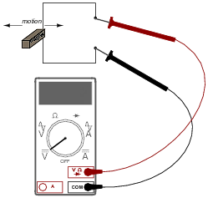
……………………………………………………

…………………………………………………………………………………………………….

…………………………………………………………………………………………………….

…………………………………………………………………………………………………….

…………………………………………………………………………………………………….

…………………………………………………………………………………………………….

…………………………………………………………………………………………………….

- In the diagram given, when moving the permanent magnet sideways to the left, the red probe attached to the positive jack of the voltmeter produces a positive reading.
Which pole of the magnet is closest to the wire? [1]

…………………………………………………………………………………………………….

- In each of the diagrams below clearly show the direction of the induced current through the resistor XY when the magnet moves relative to the coil as shown. [2]

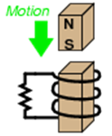  Y  X | 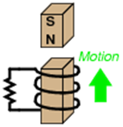  Y  X

- Consider the coil of wire located the magnetic field shown.
(a) How many turns of wire must the coil have in order to induce a voltage of 10.5 volts when exposed to a magnetic flux decreasing at a rate of 0.0075 Wb s^{–1}? [3]

- On the diagram above clearly show the direction of the induced current in the loop. [1]

- Electromechanical watt-hour meters use an aluminium disk that is spun by an electric motor. To generate a constant “drag” on the disk necessary to limit its rotational speed, a strong magnet is placed in such a way that its lines of magnetic flux pass perpendicularly through the disk’s thickness:
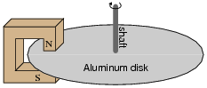
- Using the laws of induction explain the phenomenon behind this magnetic “drag” mechanism. [5]

…………………………………………………………………………………………………….

…………………………………………………………………………………………………….

…………………………………………………………………………………………………….

…………………………………………………………………………………………………….

…………………………………………………………………………………………………….

…………………………………………………………………………………………………….

…………………………………………………………………………………………………….

…………………………………………………………………………………………………….

…………………………………………………………………………………………………….

…………………………………………………………………………………………………….

- Explain how the permanent magnet assembly should be re-positioned so that it provides less drag on the disk for the same rotational speed. The poles of the magnet remain completely over the disk. [2]

…………………………………………………………………………………………………….

…………………………………………………………………………………………………….

…………………………………………………………………………………………………….

…………………………………………………………………………………………………….

- The diagram below shows a conducting bar PQ moving with constant speed, 2.00 m s^{–1}, along two parallel conducting rails 3.00 m apart. The ends of the bar touch the rails. The rails are connected by a 10.0 Ω resistor, as shown. The resistance of the bar and rails is negligible.
There is a uniform magnetic field of magnitude 0.50 T perpendicular to the bar and the rails. This field is directed into the page.
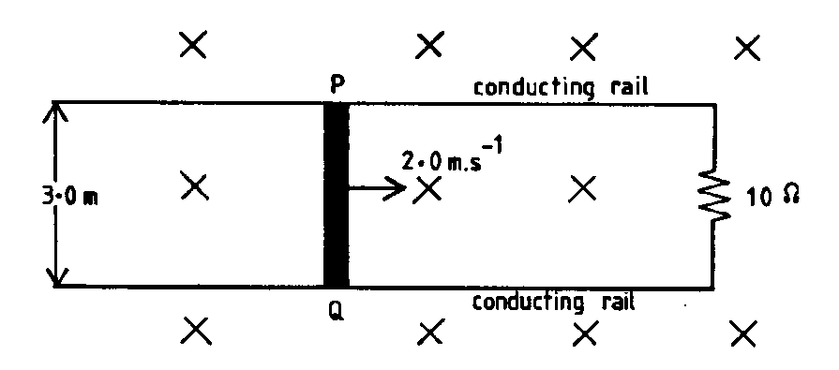
(a) What is the magnitude of the EMF induced in the bar? Show your working. [2]

(b) What is the magnitude of the force required to keep the bar moving? Show your working. [2]

- The rails are frictionless and there is good electrical contact between the bar and the rails. Why is it necessary to apply a force to keep the bar moving at a constant speed?
[2]
…………………………………………………………………………………………………….

…………………………………………………………………………………………………….

…………………………………………………………………………………………………….

…………………………………………………………………………………………………….

…………………………………………………………………………………………………….

- Two coils A and B are placed closed together, as shown below. P and Q are soft iron cores.
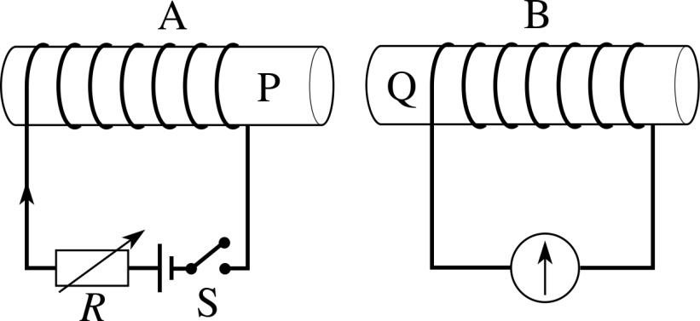
- Show the direction of the current induced in coil B when the switch in coil A is closed.
[1]

- The graph below shows how the magnet field strength changes in coil A when the switch closes.
B
(mT)
t (μs)
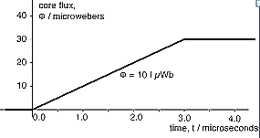
Assume that all of the magnetic flux from coil A passes through coil B which has an area of 5.0 cm².
- Calculate the emf induced in coil B. [5]

- On the axes below draw the graph of the emf calculated in (i). [3]
[t = 0 s when the switch is closed.]

- (a) A generator has a rectangular coil of side 15 cm by 12 cm that lies perpendicular to a magnetic field of flux density 4.0 T. What is the magnetic flux passing though the coil? [2]

- The coil, consisting of 20 turns of wire, is rotated and generates a peak emf of 63.5 V. Calculate the frequency with which it is being rotated. [2]

- The coil of the above generator is shown below. In Figure 7A the coil is connected to slip rings. In Figure 7B the coil is connected to a split commutator.
current  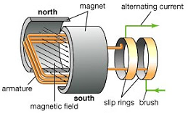  Fig 7A | current  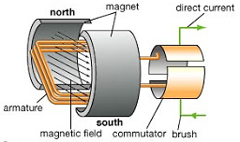  Fig 7B

- On Figure 7A clearly show the direction of rotation of the coil that induces the direction of the current shown on the diagram. [1]
- On the axes below draw the graph of the emf induced by during one rotation of each of the generators above. Assume that time t = 0 s when the coil is located in the position shown in Figure 7A and in Figure 7B.
Also indicate clearly on the graph the time when the plane of the coil is parallel with the magnetic field. [5]

Fig 7A | Fig 7B

- The following transformer is required to operate a 15 V AC device, as shown, in WA.
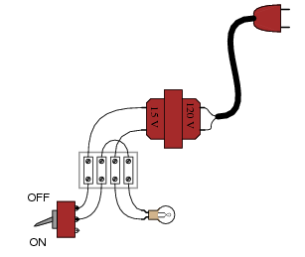
Electrical device
transformer

- Determine the turns ratio: N_{s} : N_{p} for the transformer. [2]

- Some transformers can be up to 98% efficient. Describe 2 methods used in the construction of transformers to produce this efficiency. [2]

…………………………………………………………………………………………………….

…………………………………………………………………………………………………….

…………………………………………………………………………………………………….

…………………………………………………………………………………………………….

- Suppose a power system were delivering AC power to a resistive load drawing 150 amps:

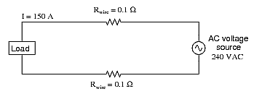
- Calculate the load voltage and the load power dissipation. [3]

- Now, suppose we were to use a pair of perfectly efficient 10:1 transformers to step the voltage up for transmission, and back down again for use at the load.

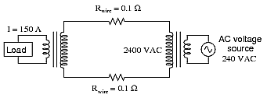

Calculate the load voltage, load power and the wasted power of this system. [5]

